

**SoundBlast**

**Supervisor:** NGUYỄN HẠ VY

**Semester:** 01

**Batch No:** T1.2302.M0

**Group No:** 01

|  |  |  |
| --- | --- | --- |
| **Order:** | ****Fullname:**** | Roll No: |
| **1.** | VŨ HOÀNG TIẾN | Student1455760 |
| 2. | CHO IN YEONG | Student1448340 |
| 3. | LÊ VĂN LINH | Student1448250 |
| 4. | VŨ PHẠM TRƯỜNG GIANG | Student1455752 |

# Month: 5 Year: 2023

# This is to certify that:

**Mr. VŨ HOÀNG TIẾN Ms. CHO IN YEONG**

**Mr. LÊ VĂN LINH**

**Mr. VŨ PHẠM TRƯỜNG GIANG**

## Have successfully Designed and Developed:

# SoundBlast

## Submitted By: Mr. VŨ HOÀNG TIẾN

# Date of issue: 08 – May – 2023

# Authorized Signature:

CONTENT

ACKNOWLEDGE 3

SYNOPSIS 4

PROBLEM DEFINITIONS 5

Requirement Specification: 6

CUSTOMER REQUIREMENTS SPECIFICATIONS 8

User: 8

Progress: 8

HARDWARE / SOFTWARE REQUIREMENT 10

*Hardware:* 14

*Software:* 14

API USER 16

API Chatbot 17

API Realtime 18

Run The Project 19

ARCHITECTURE AND DESIGN OF THE PROJECT 21

WEBPAGE INTERFACE 23

THE INTERFACE OF THE TRENDING PAGE 25

THE INTERFACE OF THE TOP CHART PAGE 26

THE INTERFACE OF THE NEW RELEASES PAGE 27

THE INTERFACE OF THE LATEST ALBUMS PAGE, THE GENRES PAGE AND THE OLD SONGS PAGES 30

THE INTERFACE OF THE TOP ARTIST PAGE 33

THE INTERFACE OF THE TOP SEARCHED SONGS PAGE 34

THE INTERFACE OF THE PLAYLIST PAGE 35

THE INTERFACE OF THE CONTACT PAGE 37

THE INTERFACE OF THE MESSAGE PAGE 38

THE INTERFACE OF THE PROFILE PAGE 39

processing information and requests of users 43

Review1: ……………………………………………………………………………

Review2: ……………………………………………………………………………

Review3: ……………………………………………………………………………

ACKNOWLEDGE

As we understand that the eProject is a step-by-step learning environment that closely simulates the classroom and Lab-based learning environment into actual implementation. It is a project implementation at your fingertips!! An electronic, live juncture on the machine that allows you to.

* Practice step by step i.e.laddered approach.
* Build a larger more robust application.
* Usage of certain utilities inapplications designed by user.
* Single program to unified code leading to a complete application.
* Learn implementation of concepts in a phased manner.
* Enhance skills and add value.
* Work on real-life projects.
* Give a real-life scenario and help to create applications that are more complicated and useful.
* Mentoring through email support.

First of all, I would like to thank India Aptech for allowing my team to work on this fantastic eProject. We had a great and valued experience with eProject this time.

Next, We would like to express my special thanks to our mentor, Ms. Ha Vy for the time and effort that she provided throughout the project. Your helpful advice and suggestions were beneficial to us during the completion of the project. In this respect, We are really appreciated and forever grateful to you.

Besides several mistakes we made in the project, we hope to have more opportunities to widen our knowledge in the web-developing world.We will try to continue to learn and improve ourselves even more in the future. And again, we are very appreciated.

Sincerely, Team 01

Group 01.

SYNOPSIS

The Objective of this program we aim is to give a sample project to work on real-life projects.These applications help us build a larger more robust application.

The objective is not to teach us HTML/JavaScript but to provide us with a real-life scenario and help us create basic applications using the tools.

Hence, we can revise the chapters before we start with the project.

This project is meant for students like us who have completed the module of HTML5. These programs should be done in the Lab sessions with the assistance of the faculty if required.

The website (in this project) is a tool that brings everything in the world to you such as historic monument information natural knowledge and skill in technology...

It is very essential for us that will have a clear understanding of the subject. We think we should go through the project and solve the assignments as per the requirements given.

And get back [***eprojects@aptech.ac.in***](mailto:eprojects@aptech.ac.in) as the assigned schedule.

**PROBLEM DEFINITIONS**

As the world’s largest music and audio platform, SoundBlast lets people discover andenjoy the greatest selection of music from the most diverse creator community on earth.

The platform has become renowned for its unique content and features, including theability to unearth breakthrough tracks, raw demos, podcasts and more. This is madepossible by an open platform that directly connects creators and their fans across theglobe. Music and audio creators use SoundBlast to share their content with a globalaudience, as well as receive detailed stats and feedback from the SoundBlast community.

Music is an extremely versatile medium of communication. It is capable of exploring allthe features that are used in verbal communication. Moreover, it does so in an explicitand structured way, which makes it an interesting and useful window into humancommunication, in general. Because of this there are many music stores across the city. And the competition for providing best of the music is growing very fast.

You are supposed to create a Single-Page-Application and responsive Website forthem with the below mentioned requirement specifications. The website is to be developed for the Windows Platform using HTML5, JSON, Angular JS, JavaScript and Geolocation. The site should work well in all leading browsers including Chrome, IE, Firefox etc.

**Requirement Specification:**

The portal will be designed as a Single-Page-Application and responsive Website witha set of pages and menus that represent choice of activities to be performed. Thepages, menus, and other visual elements must be designed in a visually appealingmanner with attractive fonts, colors, and animations. All of these should also be laid out in a responsive manner. The Website is to be created based on the following requirements.

**1)** The Top of the Page should be presented with a suitable logo

**2)** The site must contain following sections with proper listing of songs andalbums.

**- Trending Now**

**- Top Charts**

**- New Releases**

**- Latest Albums**

**- Genres**

**- Old Songs**

**- Top Artists**

**- Languages**

**- Top Searched Songs**

**3)** Gallery can be added for viewing different images.

**4)** It should also display the reviews about various albums or artists underreviews section.

**5)** Feedback must be allowed to enter by the viewer.

**6)** About Us, Site map, Gallery, about us, Queries link, Contact us link must beadded.

**7)** There would be two types of users: registered and non-registered users.

- Registered users should be able to download the complete album.

- Non-registered users should only be able to listen the album but no downloading allowed for them.

***Over and above this, the portal should implement the following functionalities:***

* Display a continuous scrolling ticker at the bottom of the page with current date,time, and location (hint: Use geolocation features of HTML5).
* Display a visitor count at the top right corner of the page beside a logo image.
* The menu options should change color on hover and also after clicking.
* Fade in and fade out options can be used for the menus.

**CUSTOMER REQUIREMENTS SPECIFICATIONS**

# User:

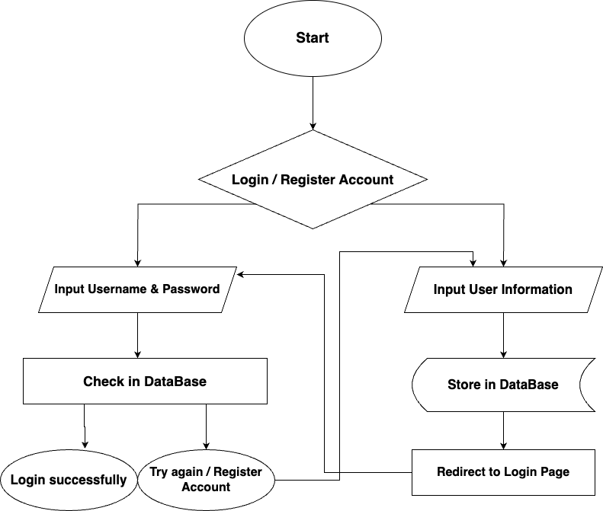

**Input:**

* Information on search.
* Data of registered members.
* Data of signed-in members.
* Feedback and compliment in chat.

**Progress:**

* Find and compare data in database
* Check the data of registered members and store that data.
* Check the data of signed-in members and store that data.
* Check, store the feedback or message of users.
* When the user clicked to any song, it searches the data and returns the results to the user.
* Check if the user is logged-in, if not logged-in user can only listen to music and can’t download it.

**Output:**

* Return result of searching and display infomation.
* Confirm the data of registered members.
* Confirm the data of signed-in members.
* Confirm the feedback or message of the users.

**All List Music:**

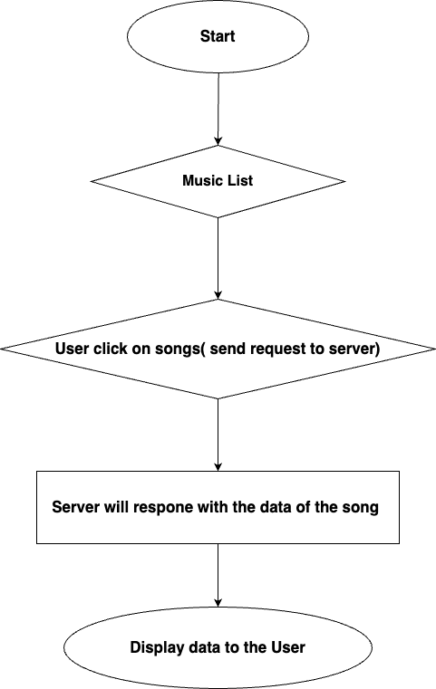**Download Songs**

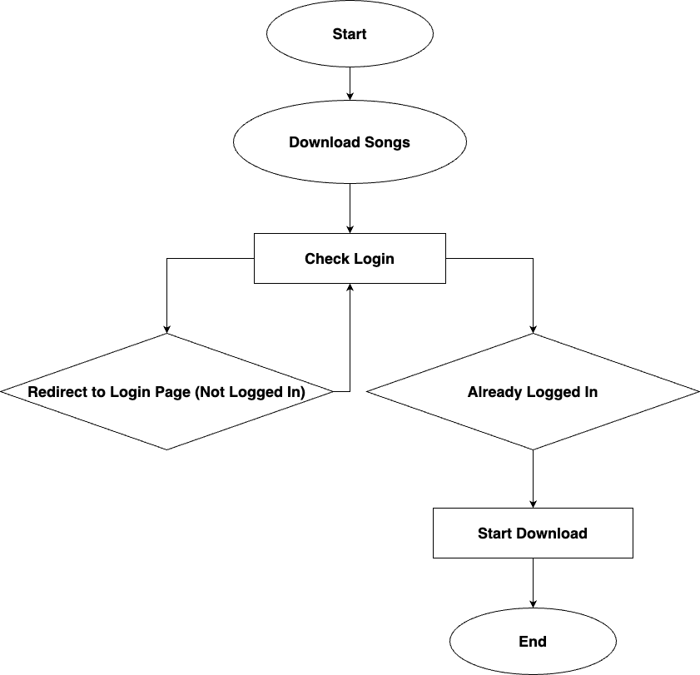

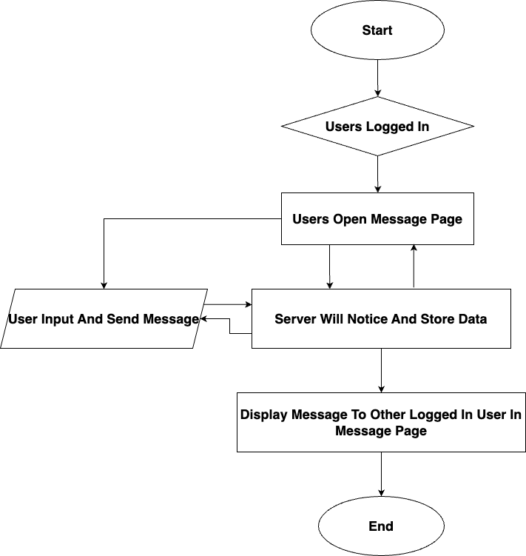**Message Page :**

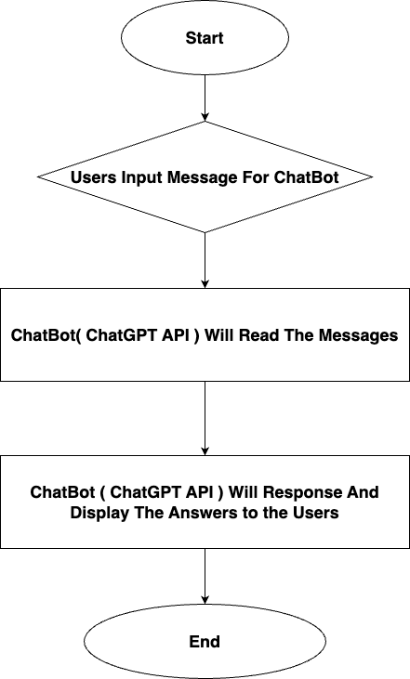**ChatBot ( ChatGPT API ):**

HARDWARE / SOFTWARE REQUIREMENT

***Hardware:***

* + A minimum computer system that will help you access all the tools in the courses is a Pentium166 or better.
  + 64 Mega bytes of RAM or better

***Software:***

* + Notepad / HTML editor
  + Dreamweaver
  + IE5.0 / Netscape 6.0

**In the project directory will include the source code and in the README.md section of the project there will be 4 link repositories to lead to the source code of the 4 APIs used in the project:**

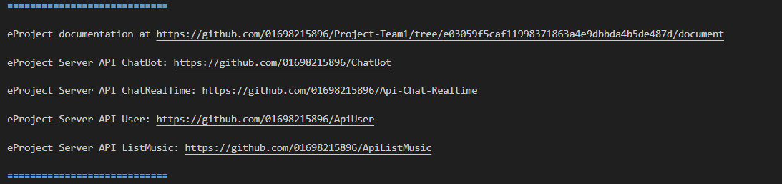**API User, API Chatbot, API Chat Realtime, API ListMusic**

**Or you can access it by following the link below**

**API User:** https://github.com/01698215896/ApiUser

**API Chatbot:** https://github.com/01698215896/ChatBot

**API Chat Realtime:** https://github.com/01698215896/Api-Chat-Realtime

**API ListMusic:** https://github.com/01698215896/ApiListMusic

**\* To run the project and the server, NPM must be installed to be able to use the commands**

**API USER**

**Turn on the API User folder in Visual Studio Code then open the Terminal and execute the following commands to run the API User server.**

**Install NodeJS (** [**https://nodejs.org/en**](https://nodejs.org/en) **, Version: 18.16.0 )**

**- Use this following commands:**

* **npm install express** ( install express library, Version 4.18.2 )
* **npm install cors** ( Version 2.8.5 )
* **npm install dotenv** (Version 16.0.3 )
* **npm install mongoose** ( Version 7.2.0 )

**After the installation is complete, go to the package.json file to check if the libraries have been installed successfully or not.**

**Execute this following command to run the server:**

* **node server.js**

**Note:**

**- The User API has been deployed on to:** [**https://cyclic.sh/**](https://cyclic.sh/)

**- There is no need to run the server under local host, here is the API link:**

[**https://odd-gold-bighorn-sheep-boot.cyclic.app/users**](https://odd-gold-bighorn-sheep-boot.cyclic.app/users)

**API Chatbot**

**Turn on the API Chatbot folder in Visual Studio Code then open the Terminal and execute the following commands to run the API Chatbot server.**

**Install NodeJS (** [**https://nodejs.org/en**](https://nodejs.org/en) **, Version: 18.16.0 )**

**- Use this following commands:**

* **npm install express** ( install express library, Version 4.18.2 )
* **npm install cors** ( Version 2.8.5 )
* **npm install dotenv** (Version 16.0.3 )
* **npm install openai** (to be able to use OpenAI’s API provided)

**After the installation is complete, go to the package.json file to check if the libraries have been installed successfully or not.**

**Execute this following command to run the server:**

* **node server.js**

**Note:**

**- The Chatbot API has been deployed on to: https://render.com/**

**- There is no need to run the server under local host, here is the API link:**

[**https://apichatbox.onrender.com**](https://apichatbox.onrender.com)

**API Realtime**

**Turn on the API Realtime folder in Visual Studio Code then open the Terminal and execute the following commands to run the API Realtime server.**

**Install NodeJS (** <https://nodejs.org/en> **, Version: 18.16.0 )**

**- Use this following commands:**

* **npm install express** ( install express library, Version 4.18.2 )
* **npm install cors** ( Version 2.8.5 )
* **npm install dotenv** (Version 16.0.3 )
* **npm install socket.io** ( Version 4.6.1 )

**After the installation is complete, go to the package.json file to check if the libraries have been installed successfully or not.**

**Execute this following command to run the server:**

* **node server.js**

**Note:**

**- The Realtime API has been deployed on to: https://render.com/**

**- There is no need to run the server under local host, here is the API link:** [**https://apichatrealtime.onrender.com**](https://apichatrealtime.onrender.com)

**API ListMusic**

**Note:**

**- The ListMusic API has been deployed on to: https://** **vercel.com/**

**- There is no need to run the server under local host, here is the API link: https://apiuser-self.vercel.app/**

**Run The Project**

**Turn on the project folder in Visual Studio Code then open the Terminal and execute the following commands to run the project:**

* **npm** install @angular/cli
* **npm serve –o** ( will run the project and open the project on the browser )

ARCHITECTURE AND DESIGN OF THE PROJECT

**Home**

**Latest Album**

**Genres**

**Top Artists**

**Trending Now**

**New Releases**

**User**

**Old Songs**

**Top Searches**

**Top Charts**

**Sign Up**

**Log In / Out**

Interact With Web At Homepage

***After run the project successfully, it will have an interface like this:***

**- On the left side will be a navbar with items for users to choose:**

* **Trending Now**
* **Top Charts**
* **New Releases**
* **Latest Album**
* **Genres**
* **Old Song**
* **Top Artists**
* **Top Searched Songs**
* **Playlist**
* **Languages**
* **About Us**
* **Message**

**- The rest will be:**

* **Search Bar**
* **Login**
* **Website Content**
* **ChatBot**

**What it looks like when the user clicks:**

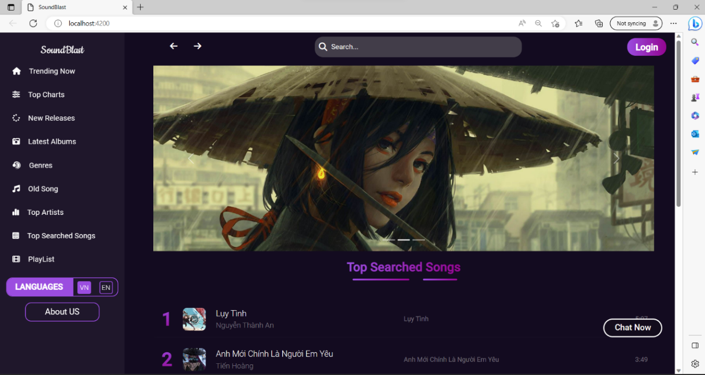**WEBPAGE INTERFACE**

* **Trending Now page:** Will show all the popular albums

**- By default every pages have a navbar:**



**1: There are 2 buttons that can go back to the previous page or forward to the page we just backed.**

**2: Search box can search for songs.**

**3: When the user successfully login, a frame will be displayed for the user to click, after clicking, the user will have 2 options to choose from: Profile and Account Logout.**

**- The navbar frame on the left will display the navbar list, besides there is also a Playlist to save the user’s favorite playlist and Message can chat with each other.**

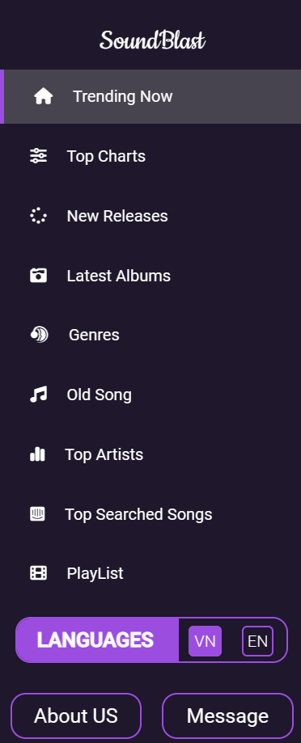

**THE INTERFACE OF THE TRENDING PAGE**

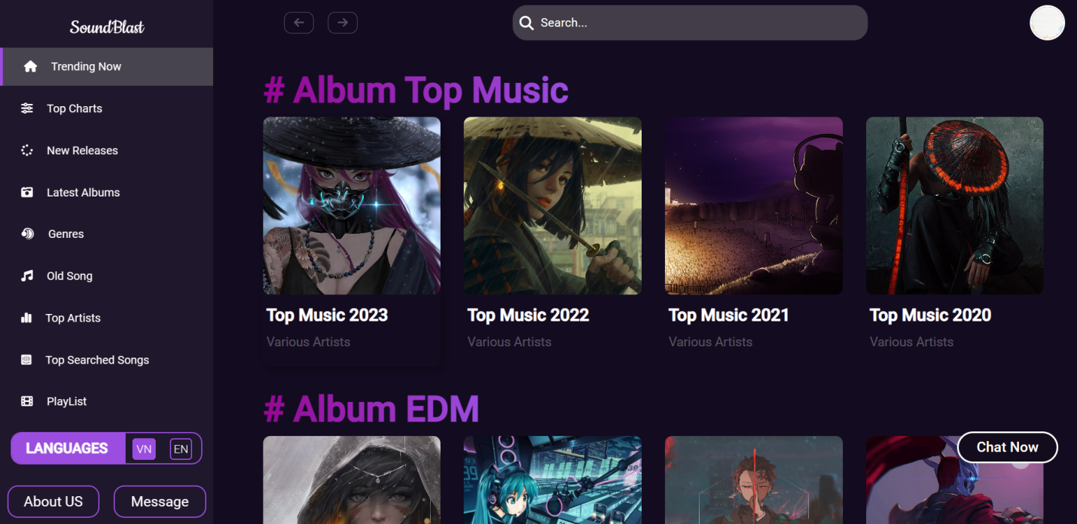

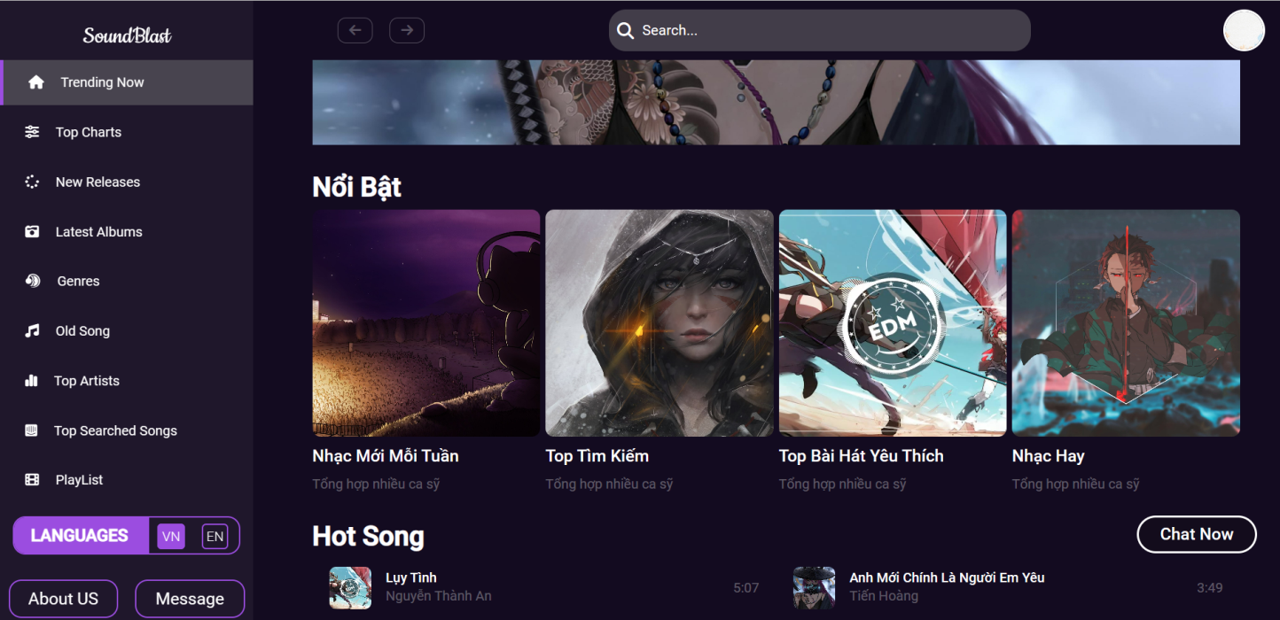When the user clicks on trending, the interface will have 2 parts: Album Top Music and Album EDM, each Album has 4 options for users to choose from, after clicking on the option, the user will be redirected to the page. This will synthesize outstanding songs and have a list of hot songs for users to choose.

**THE INTERFACE OF THE TOP CHART PAGE**

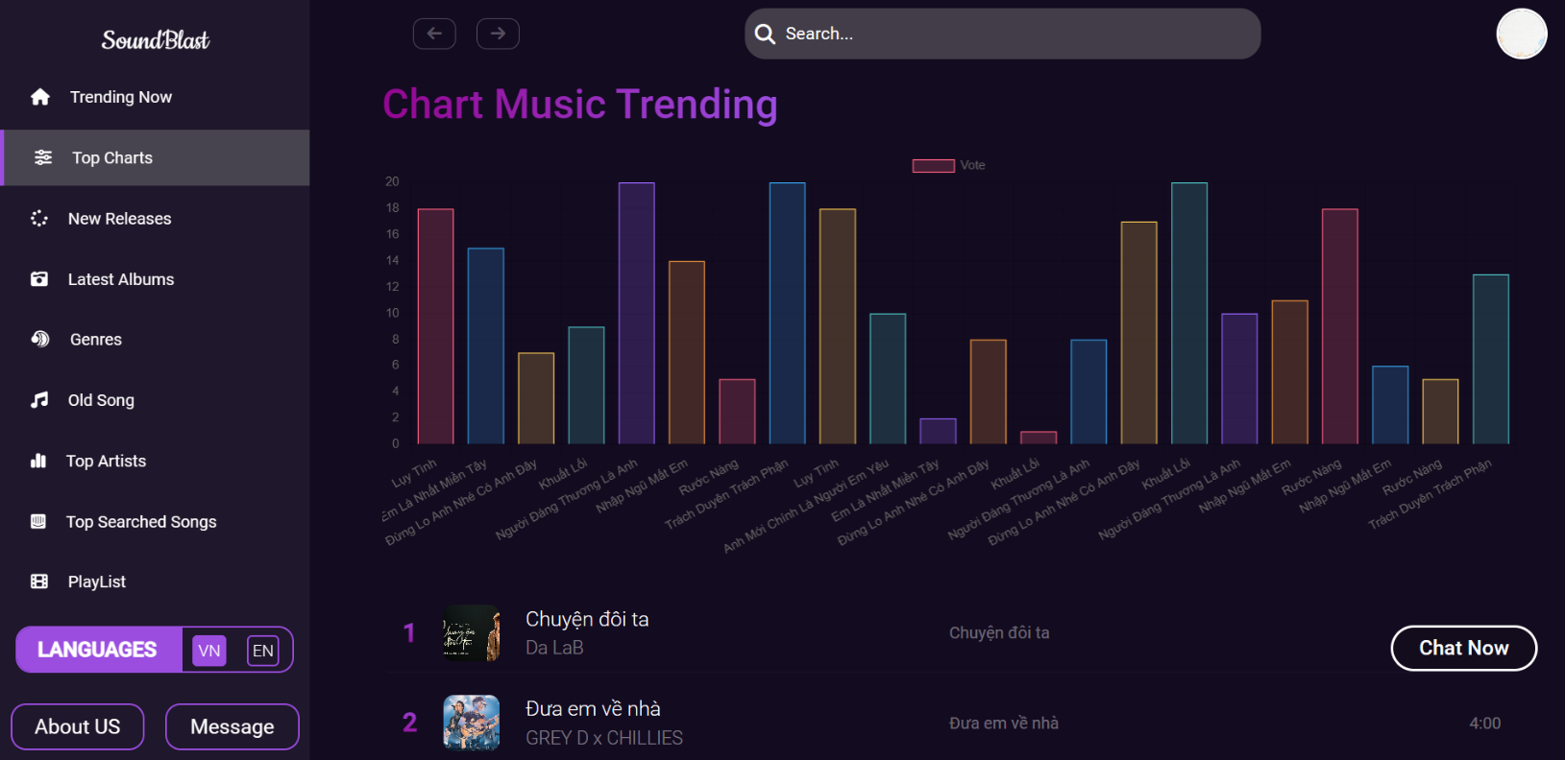

When the user clicks on Top charts, there will be 2 parts:

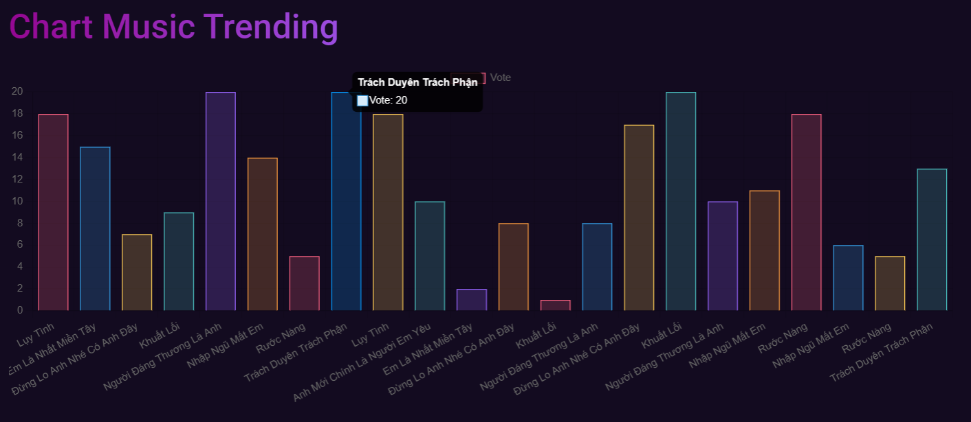 - First, there will be a chart to show the songs with the most votes, when the user clicks on any bar, it will show the song name and the number of votes.

- Second, there will be a list of suggested songs for the user.

**THE INTERFACE OF THE NEW RELEASES PAGE**

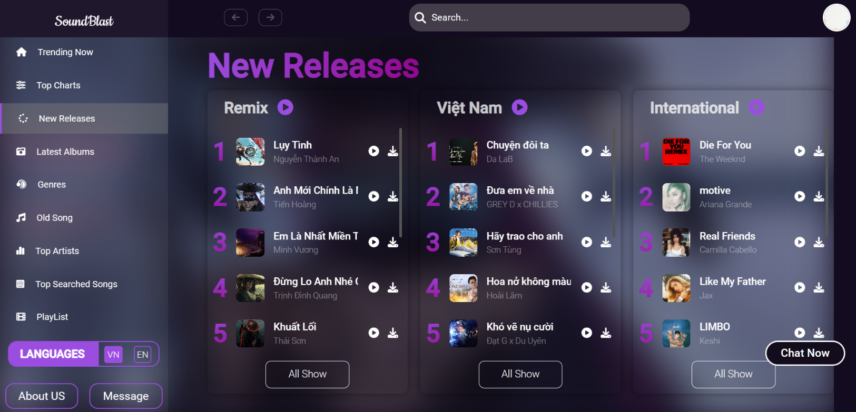

When the user clicks on New Releases, there will be 3 parts:

- List of Remix music

- List of Vietnamese music

- List of international music

And there are 2 buttons for users to choose from:

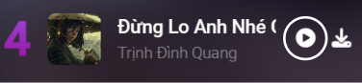

**When the users clicks on play button, there will be a slider to open the music.**

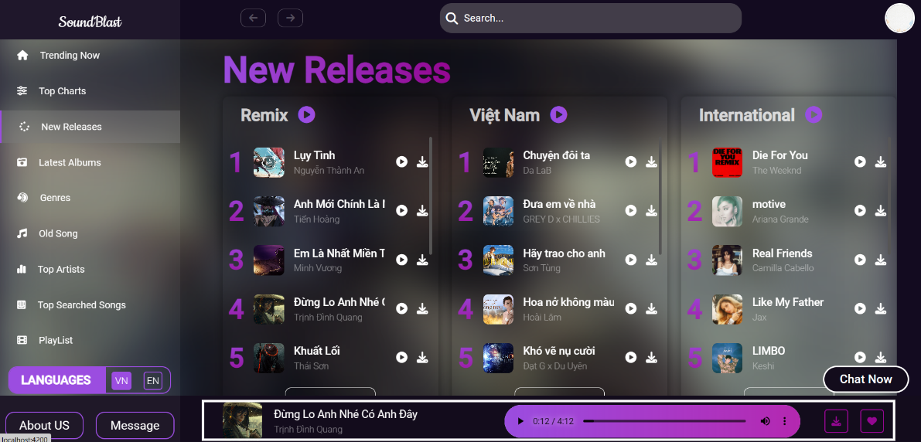In the music frame will have the song name, singer, options such as volume, pause and play and there are 2 buttons.



When the user clicks this button, the song will be downloaded provided that the user is logged in, and if the user is not the logged in, then redirects the user to the login page to log in, if successful, allows the user to download music.

When the user clicks this button, the song will be added to the user’s Playlist provided that the user is logged in, and if the user is not logged in, then redirect the user to the login page to log in. if successful, allow User added to Playlist.

And when the user clicks on the song name area, he will be redirected to the music page, this is the interface when the user clicks:

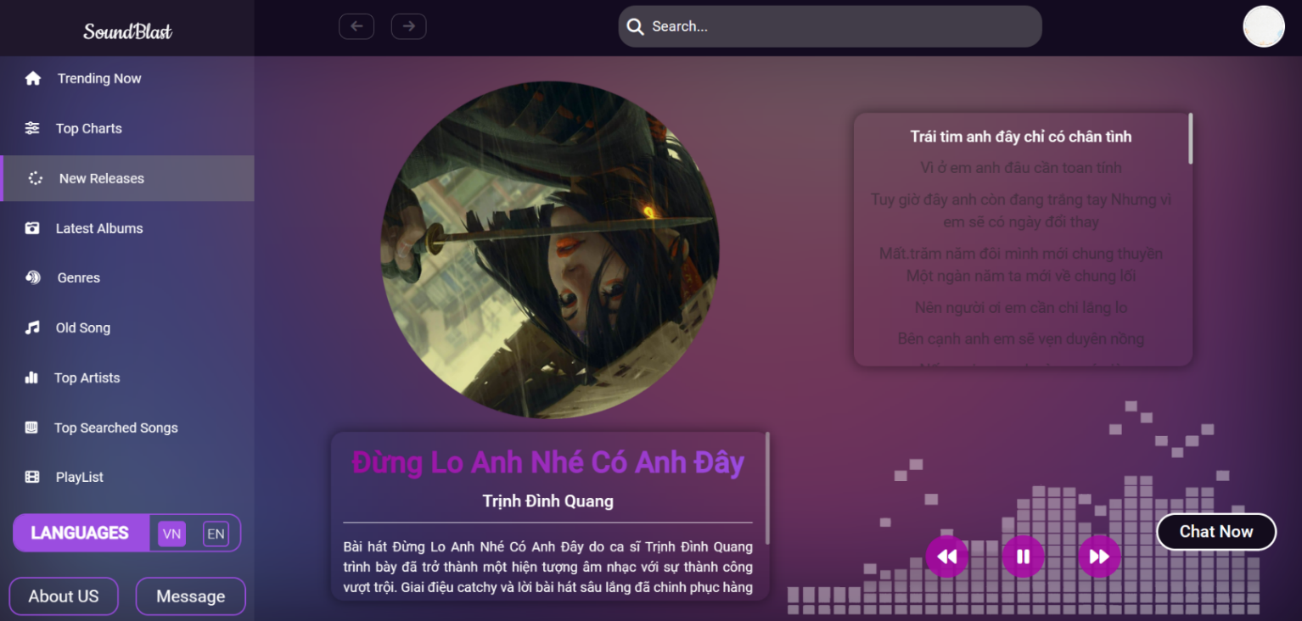

In this page will include images, song title, artist name, description of the song, and especially the lyrics will be displayed and automatically scroll down throughout the song when the song plays.

There are also 3 buttons to switch songs and 1 button in the middle to pause and play. Because this is a music page when the user clicks to any songs, the 2 buttons to switch song will not be used, only the pause and play buttons are used.

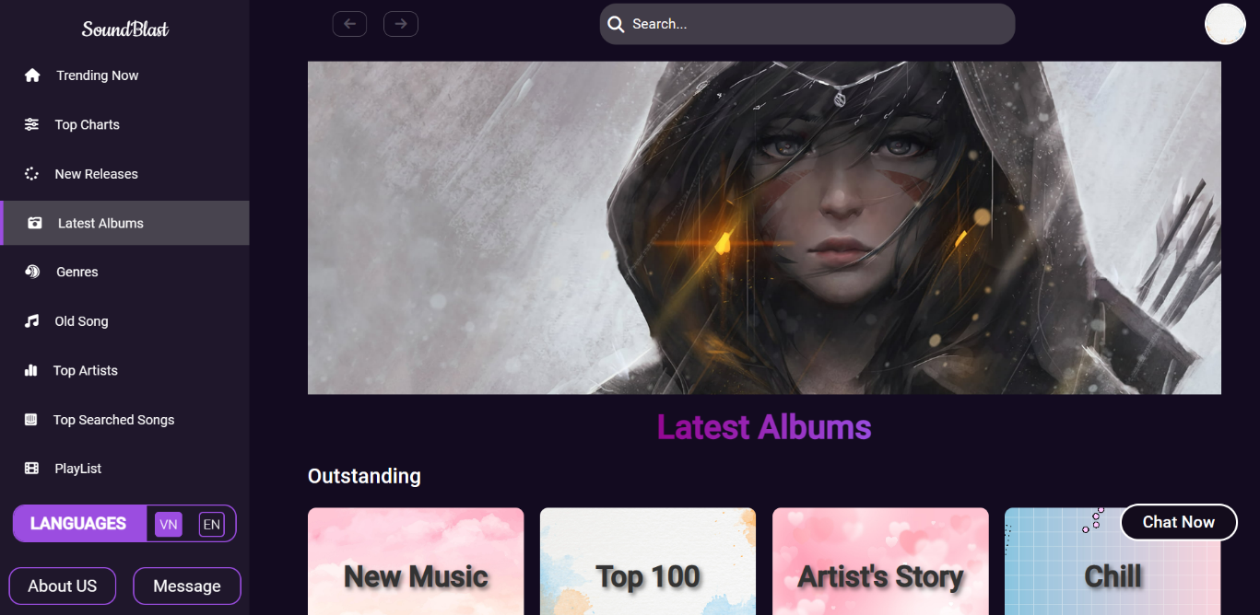**THE INTERFACE OF THE LATEST ALBUMS PAGE, THE GENRES PAGE AND THE OLD SONGS PAGES**

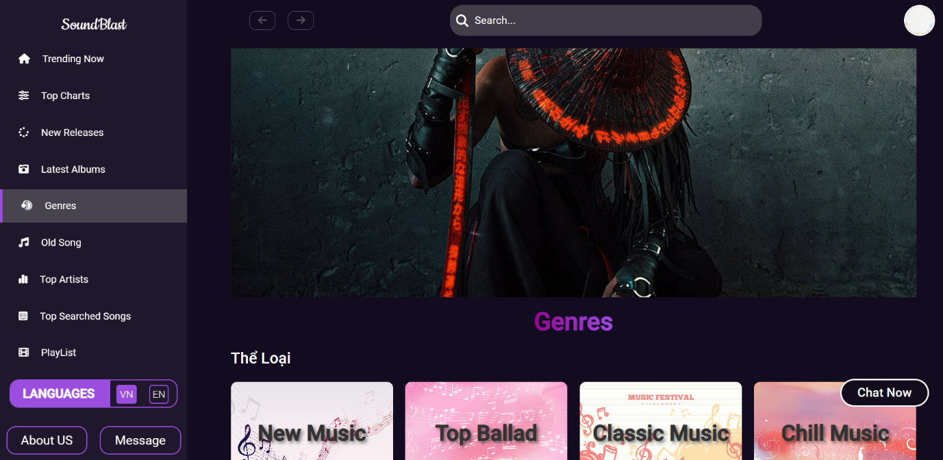

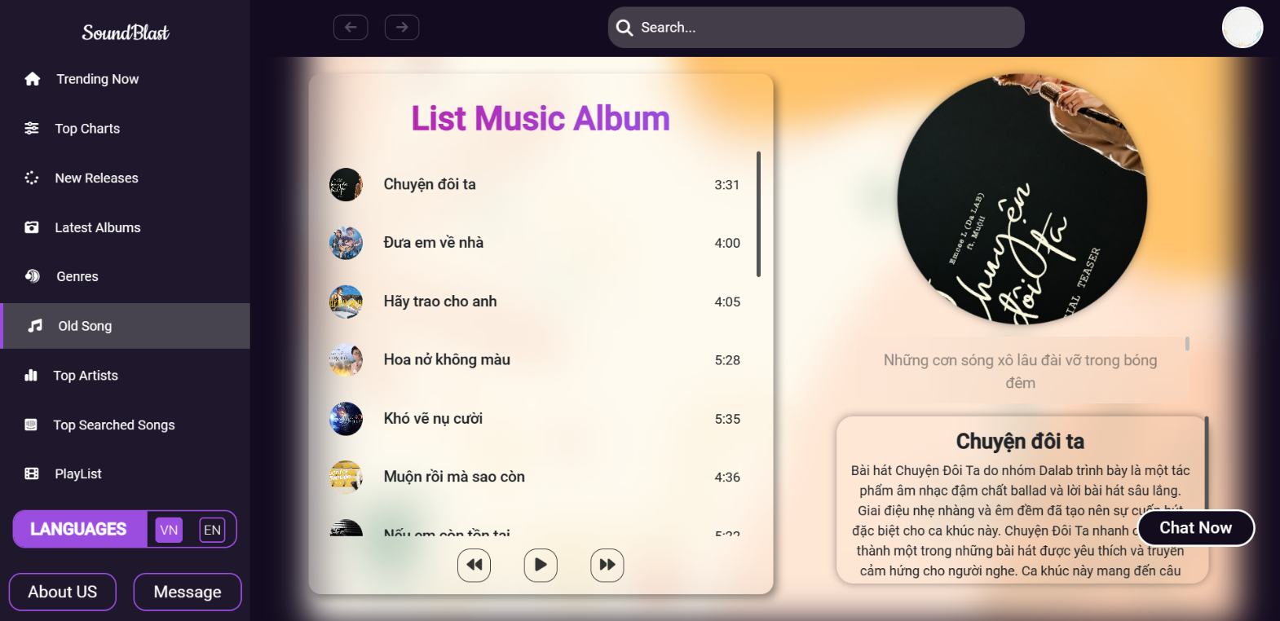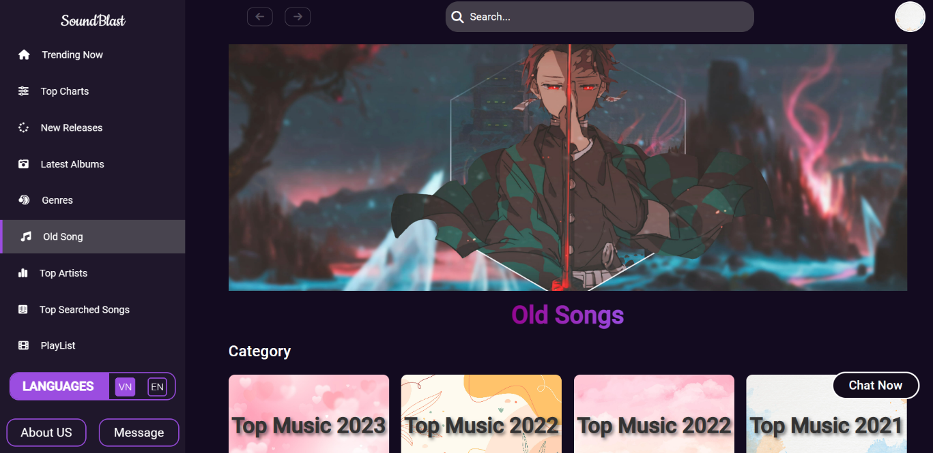Basically, the interface is the same but there will be different options and when users click on any album, they will be redirected to the music page and display the album list as shown below:

This page will display the list of albums that the user has selected that will include the music list, the song image, the name of the singer, the title and the lyrics will also run with the music. There are also 3 buttons including 2 buttons to switch songs and 1 button in the middle to pause and play.



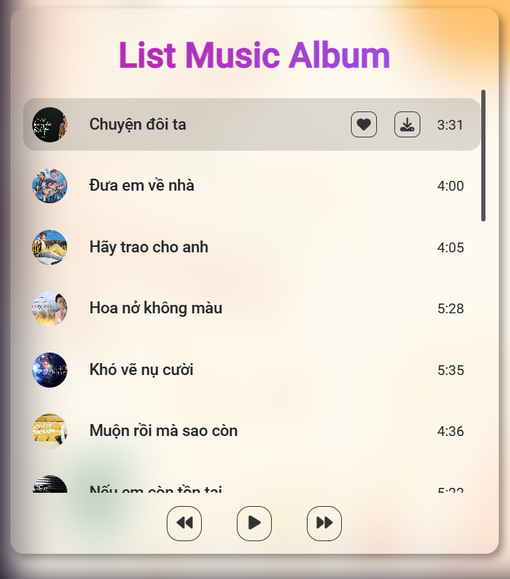**When the user hovers over any song in the list, two buttons will appear for the user to choose to add to the Playlist and download the song:**

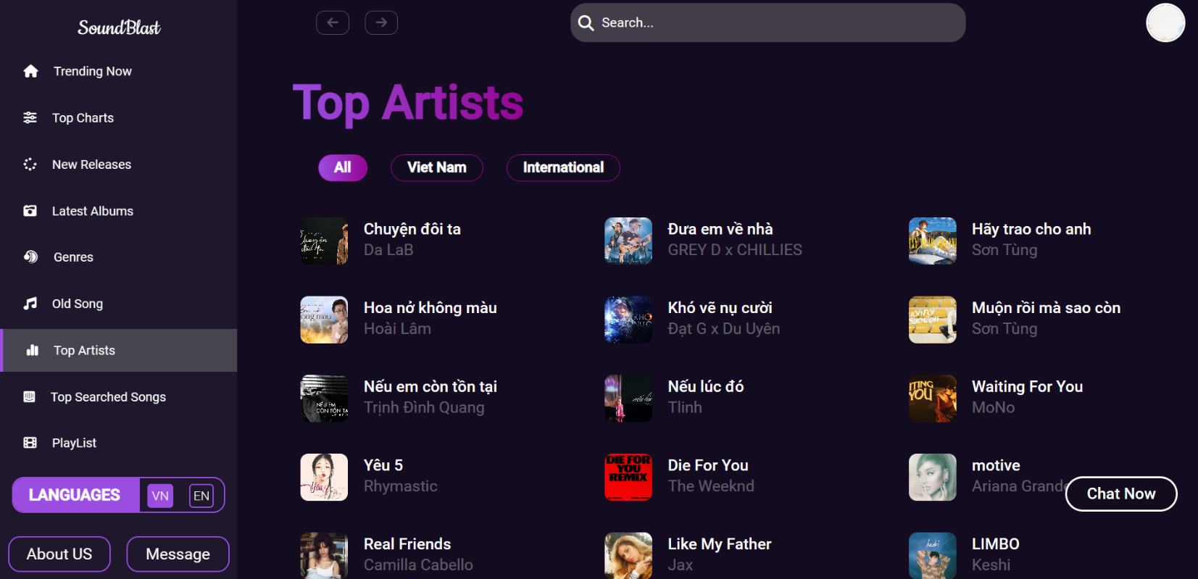**THE INTERFACE OF THE TOP ARTIST PAGE**

**This page will show a list of songs and there will be 3 options for users to choose:**

**- All: Will display all songs**

**- Vietnam: Will display Vietnamese songs**

**- International: Will display International songs**

And when the user clicks on any post, there will be a slider like the New Releases page and the options are the same.

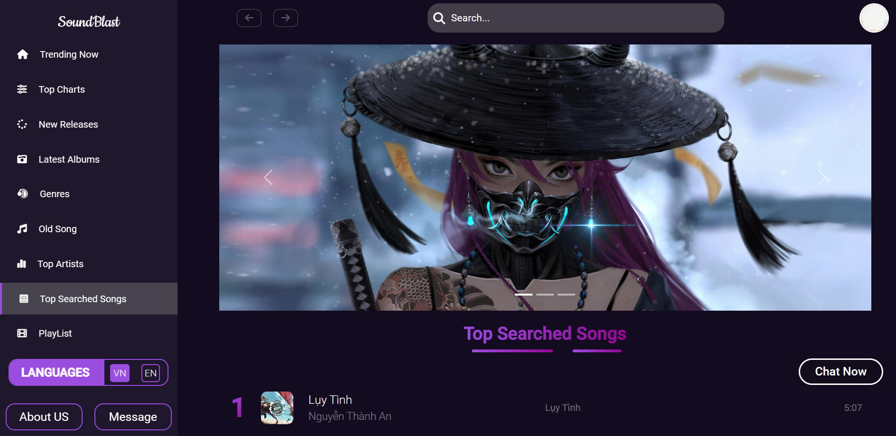**THE INTERFACE OF THE TOP SEARCHED SONGS PAGE**

**- This page will show the most searched songs.**

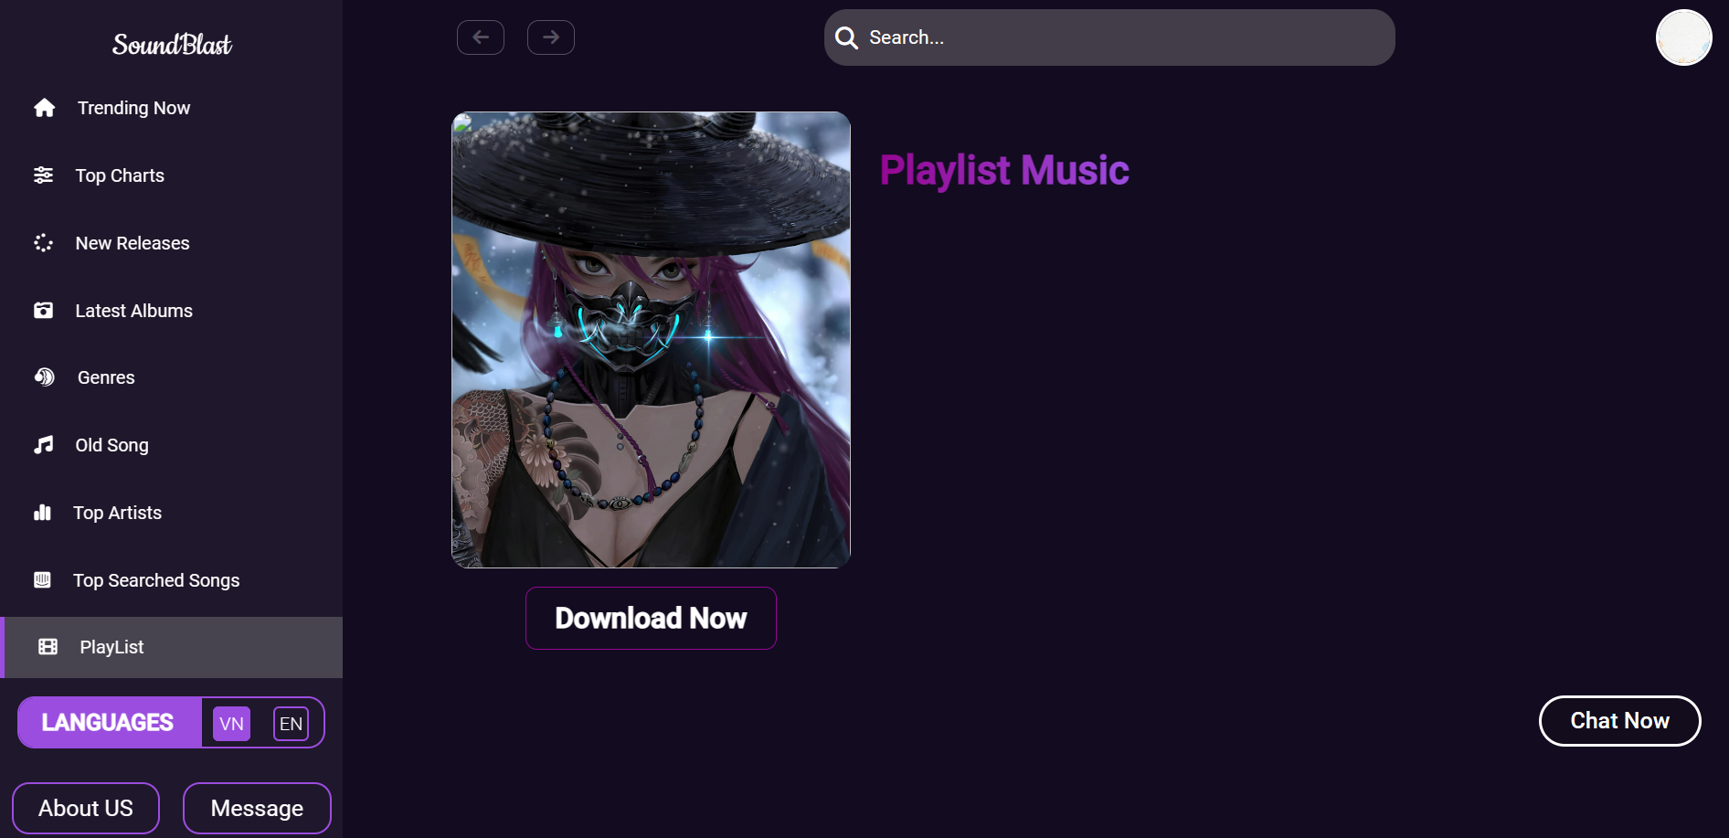**THE INTERFACE OF THE PLAYLIST PAGE**

**- When the user clicks on the add to playlist button, the song will be transferred to this page to save for the user.**

**THE INTERFACE OF THE LANGUAGES**

The project will be supported in 2 languages: Vietnamese and English

The website is in English by default

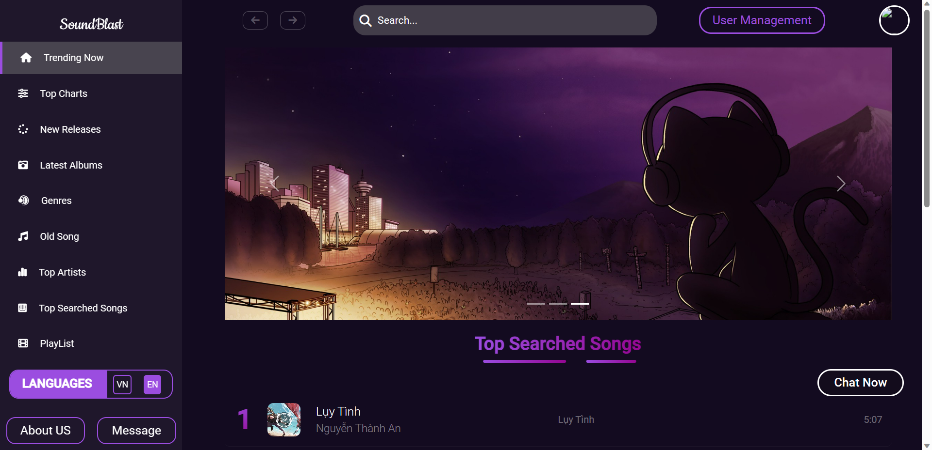

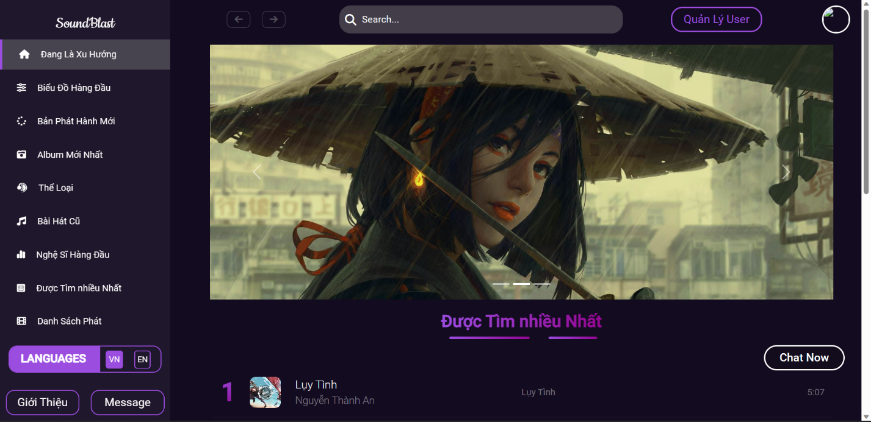When the user clicks on VN, the website will be converted to Vietnamese

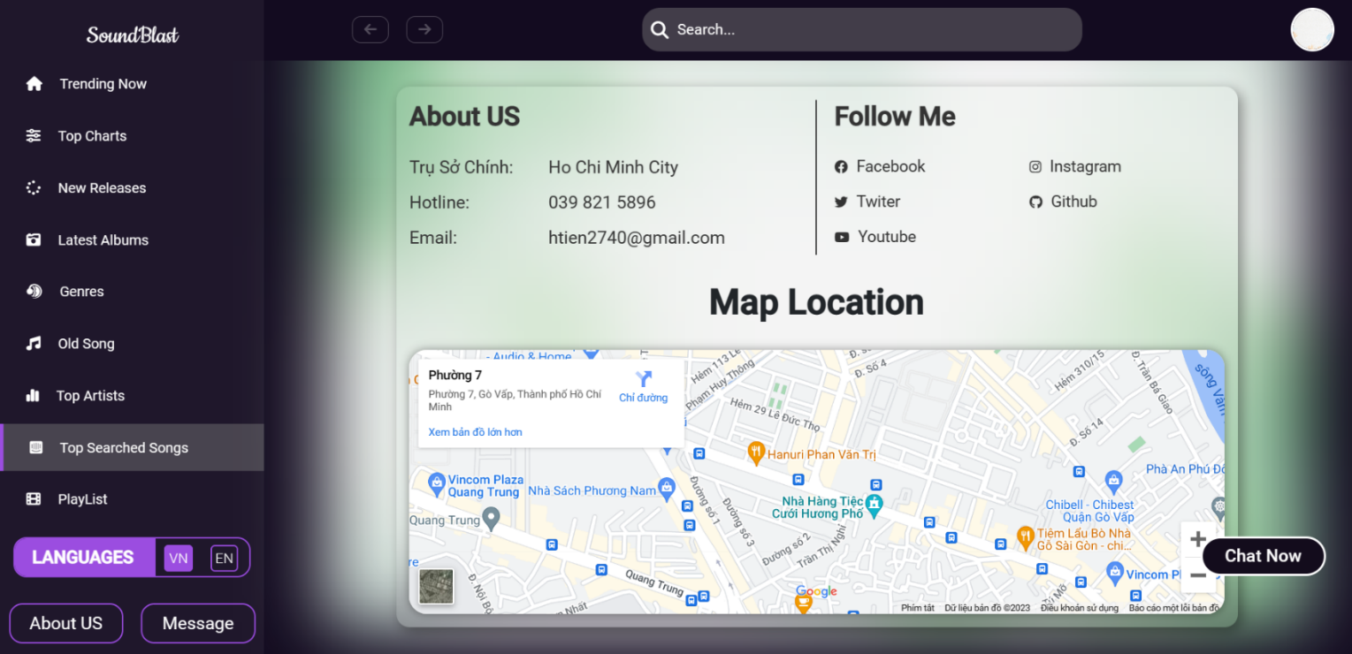**THE INTERFACE OF THE CONTACT PAGE**

**- This page will show About Us, Follow Me and Map Location.**

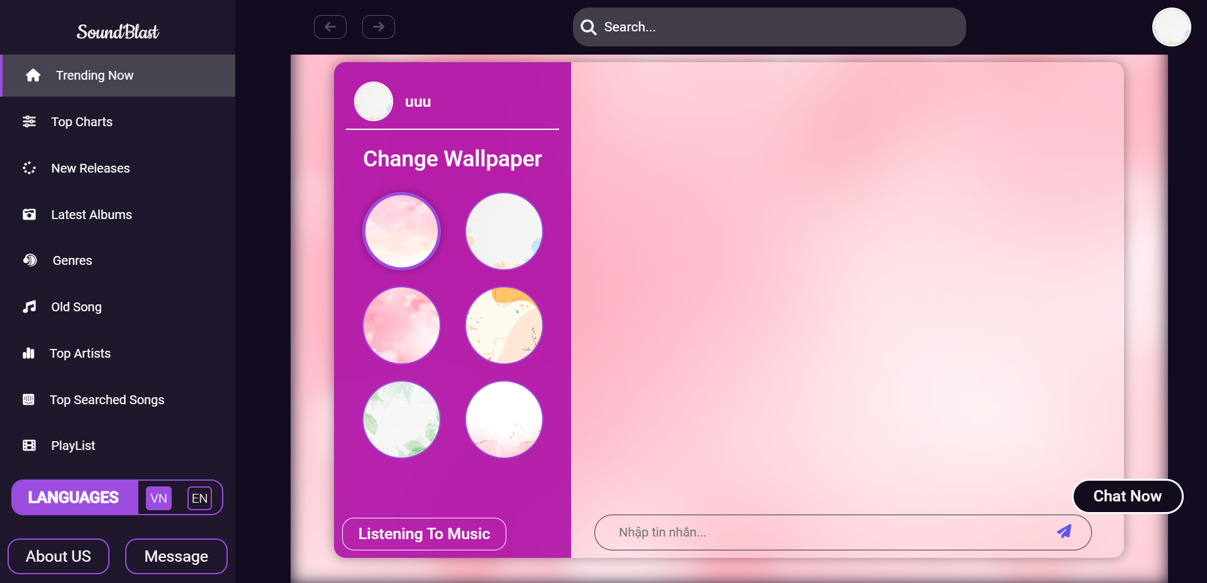**THE INTERFACE OF THE MESSAGE PAGE**

**- This page will display the user’s avatar and username, the user can change the background image and can click Listening To Music to be able to listen to music and text at the same time.**

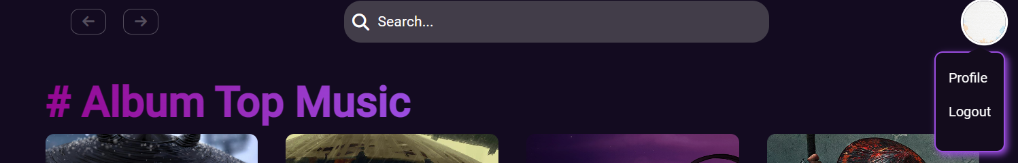**THE INTERFACE OF THE PROFILE PAGE**

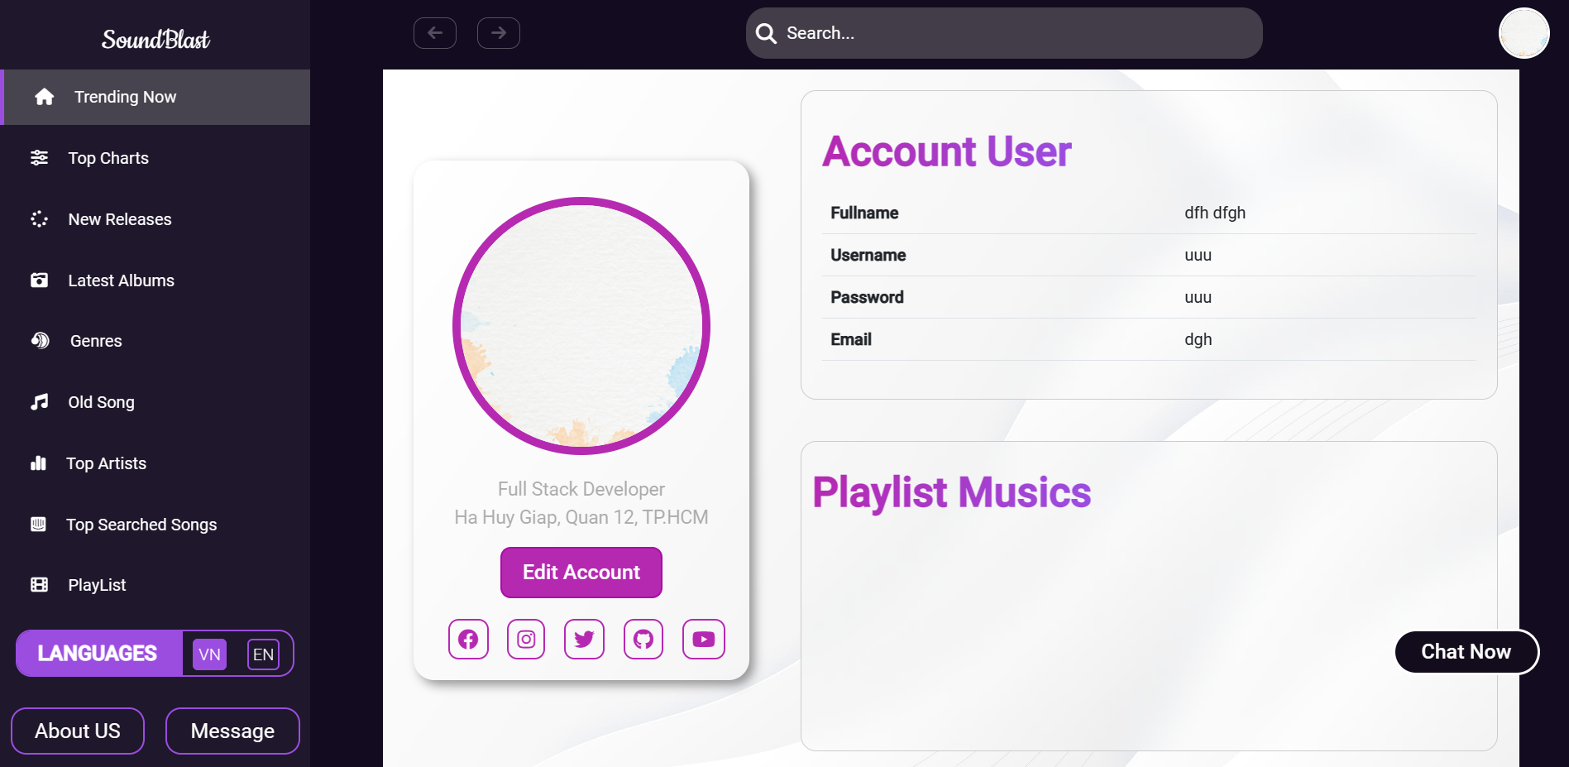

**- In the user’s Profile will display the user’s Avatar and information and the user can change the account information and follow their own personal playlist.**

***Some actions users can do:***

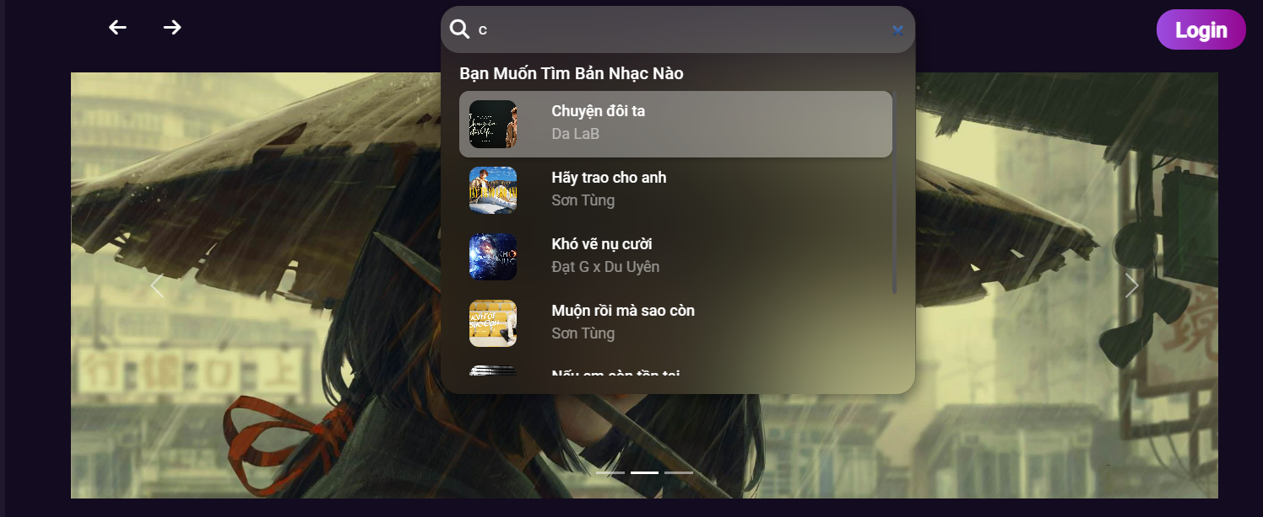 **- You can search for your favorite song through the search bar*.***

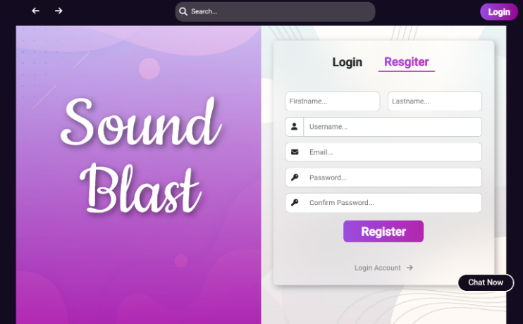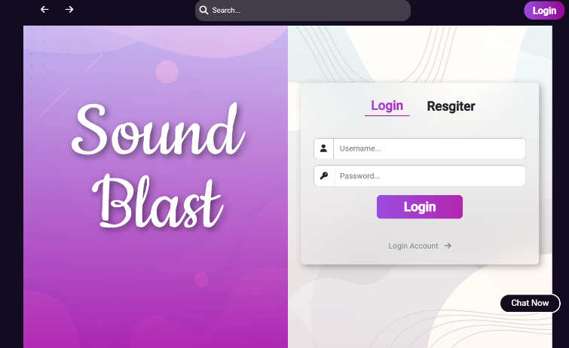**- Can create a new account of logging in to an existing account*.***

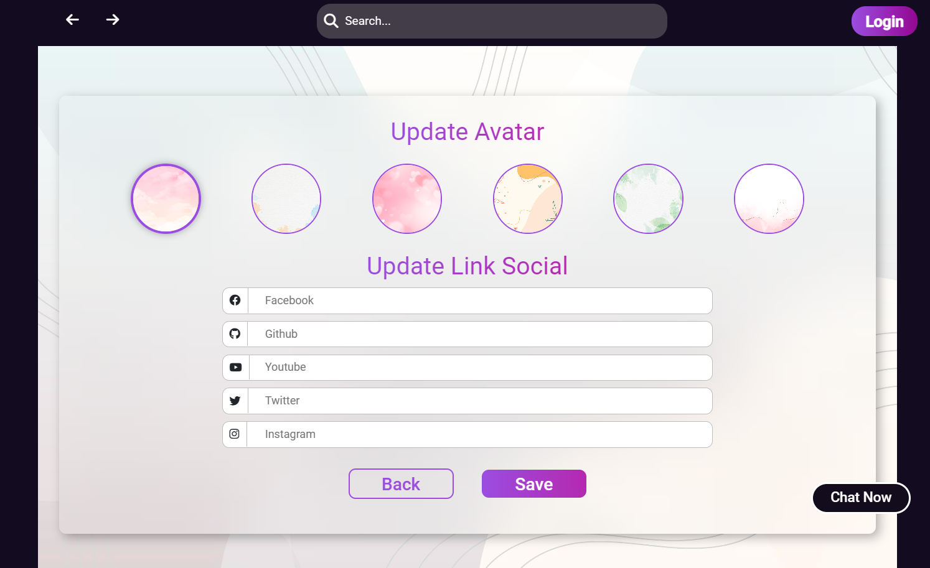**- After the user successfully create a new account and logs in*,* it will redirect the user to the page to update the profile picture and social links, is the user does not want to update, they can press back to be redirected to the homepage.**

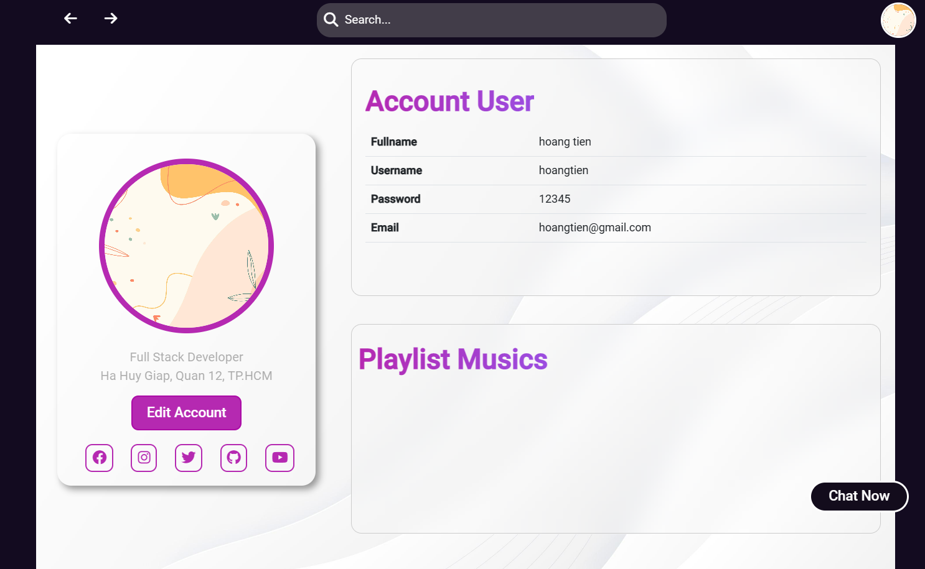**- After the user successfully logged in and updated the information and pressed save button*,* the user will be redirected to the profile page to review the updates.**

***-* In the user profile, you can see the account details and can edit the account, can see songs you added to your personal playlist.**

**- In addition, there will be one admin account to manage all Users:**

**Admin Account:**

* Username: **admin**
* Password: **admin**

**- After logged in successfully to the admin account there will be a User Management button next to the search bar.**



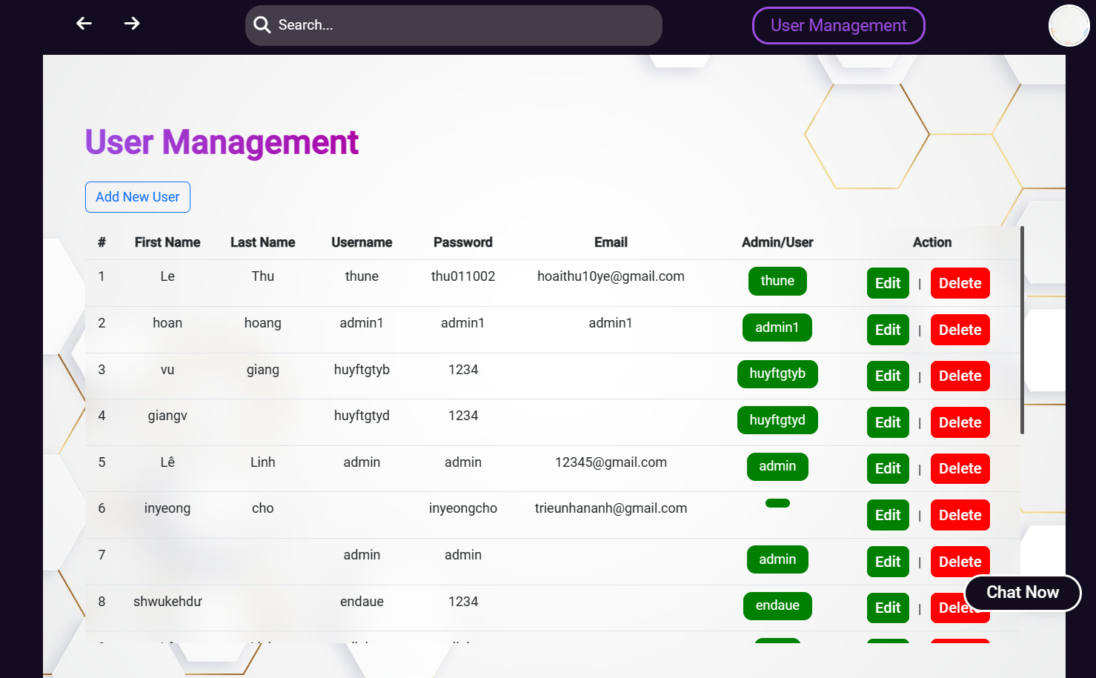***-* After clicking, you will be taken to the User Management page, in this page the admin can add, edit, delete Users and see the list of registered users.**

processing information and requests of users

- If the user registers a new account, after the user successfully registers, the user’s information will be updated to the mongoDB database and store the user’s information.

- If the user logs in then get the data in the user’s login form and compare it with the data in the database. If the username and password are similar to the username and password in the database, notify the user that the login is successful and send the user’s data. Content to the website and save the user’s username to localstorage for later testing.

- When the user wants to download the song, we must check that on localstorage if there is user’s username information, then allow the user to download. And if there is no username, then redirect the user to the login page to log in and download the song.

- When the user searches for any song, it must take the user’s data to enter and filter to filter in the data to store the song data and show the song the user wants to search.

- When the user clicks on favorite or adds to the playlist, it will save the data of the song the user chooses and update it to the database to save the song information.